# CS 255 System Design Document Template

This template lays out all the different sections that you need to complete for Project Two. Each section has guidance to prompt your thinking. You will need to continually reference the interview transcript as you work to make sure that you are addressing your client’s needs. There is no required length for the final document. Instead the goal is to complete each section based on what your client’s needs are. Remove this note when you are finished, and replace all bracketed text with the relevant information.

## UML Diagrams

### UML Use Case Diagram

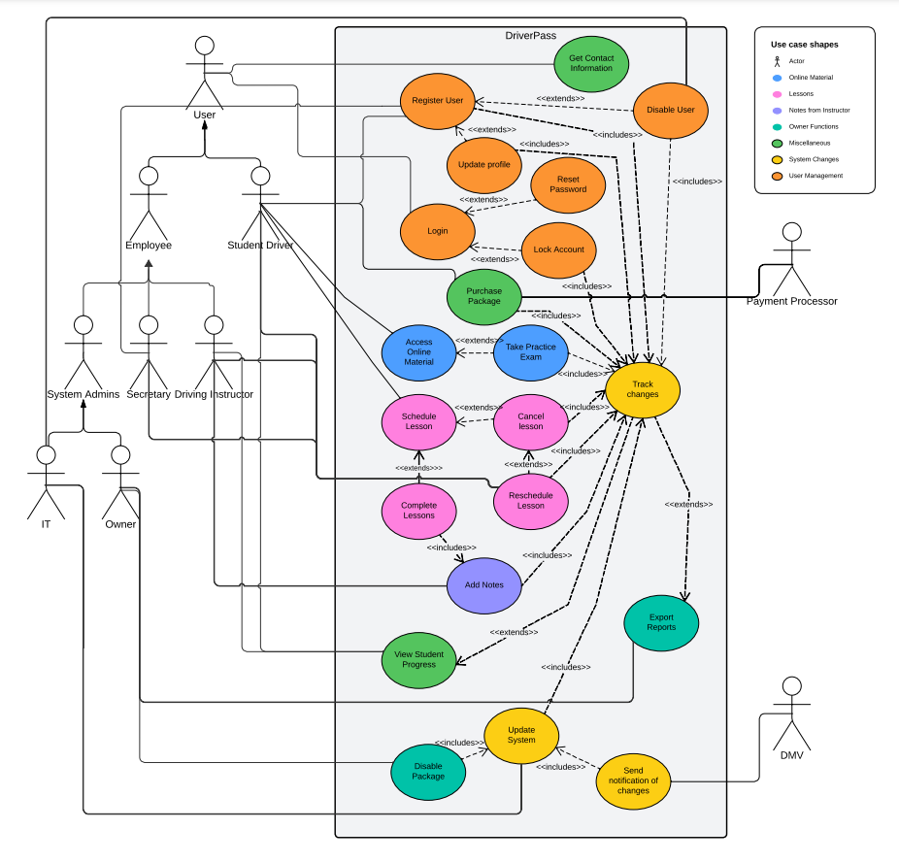

### UML Activity Diagrams

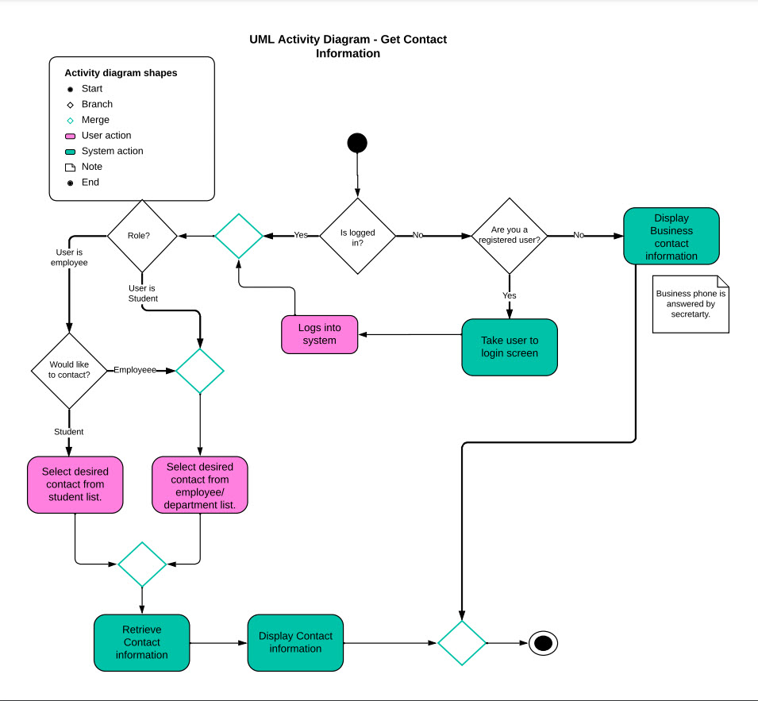

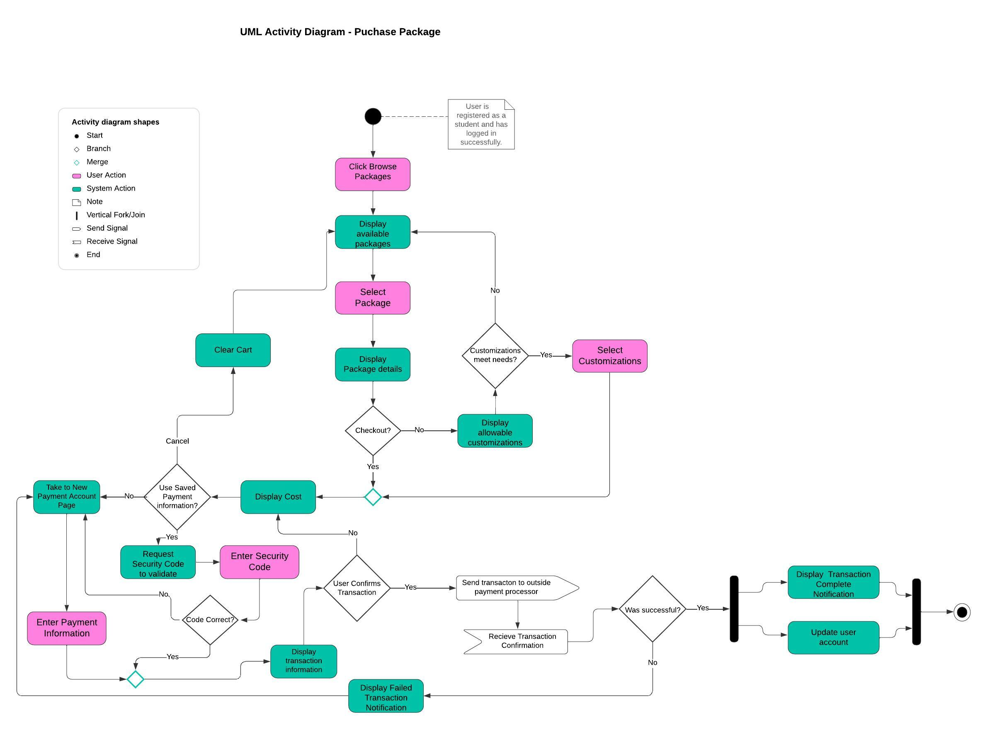

### UML Sequence Diagram

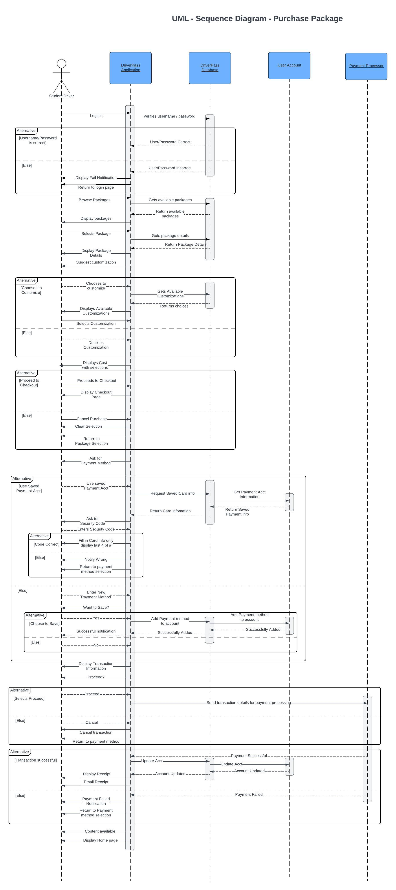

Sequence Diagram is continued on the next page.

Last activity is repeated to show where diagram continues from.





### UML Class Diagram

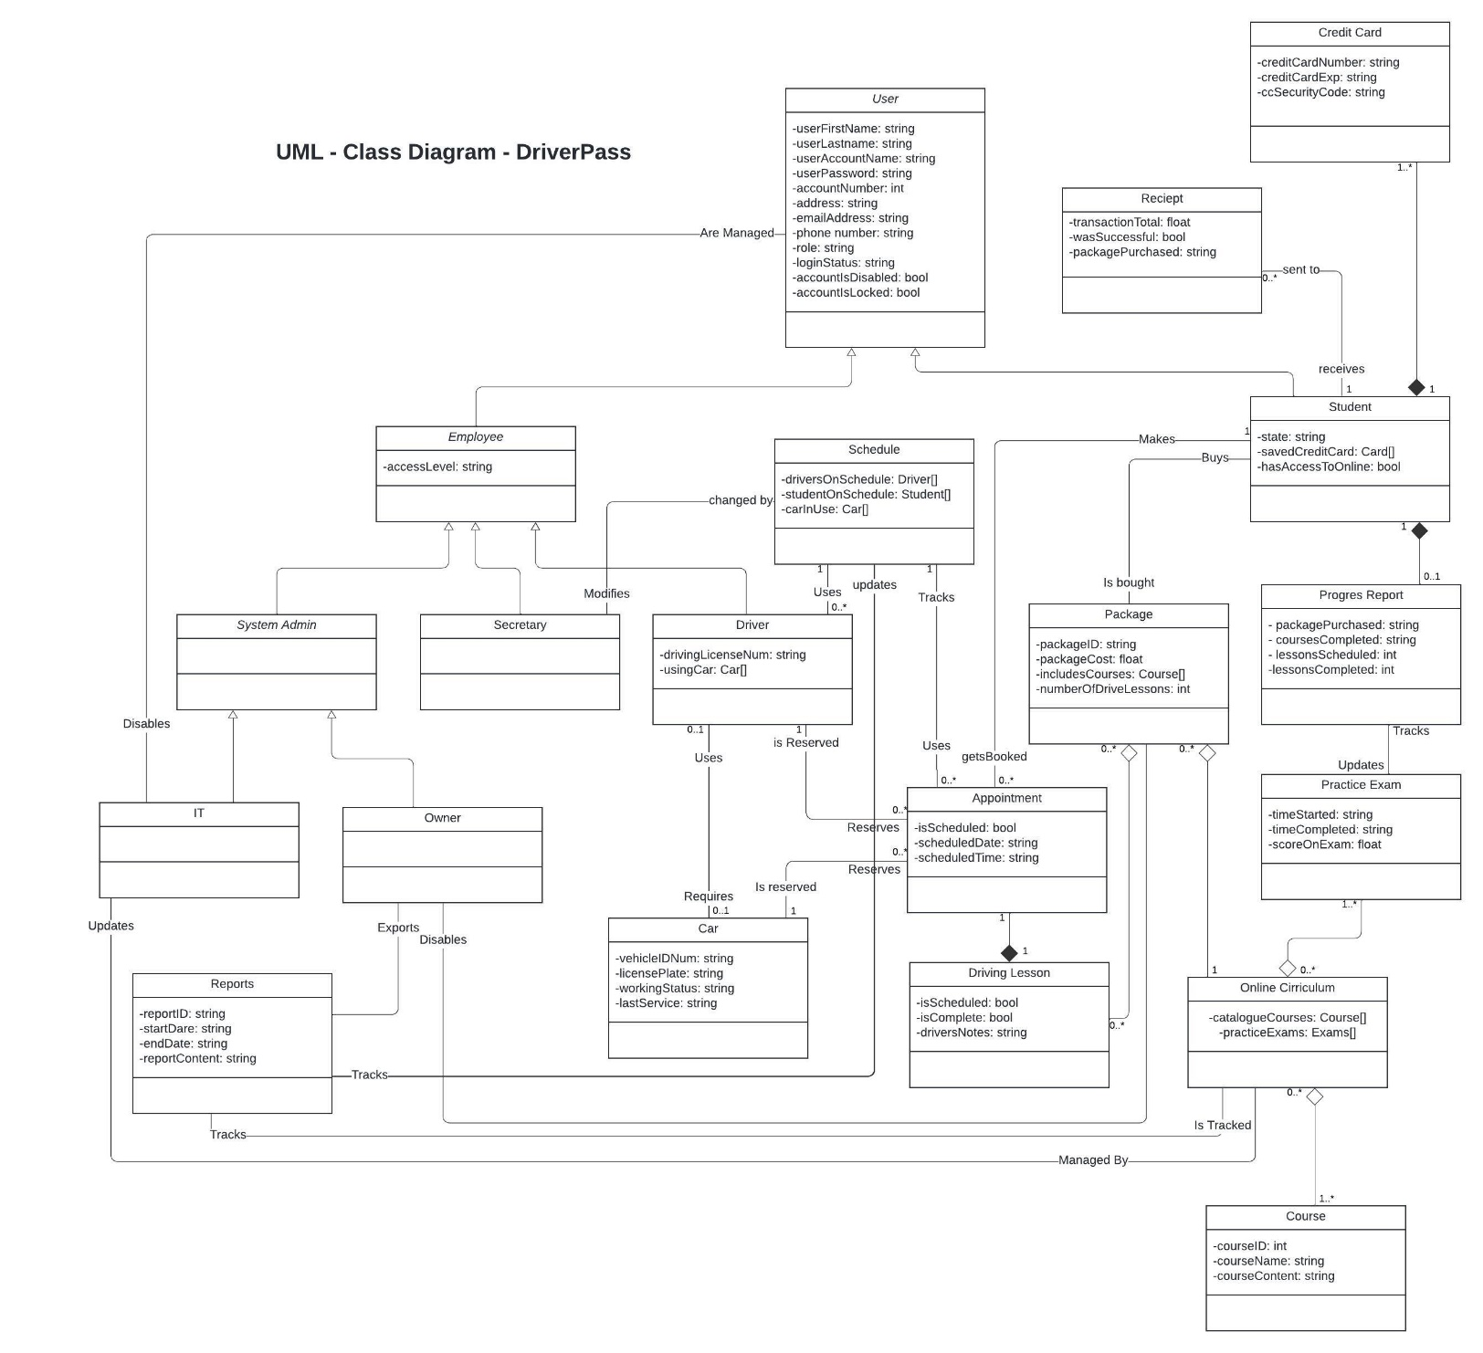

## Technical Requirements

*[Based on the diagrams you have created, describe the technical requirements of your system. These requirements should address the required hardware, software, tools, and infrastructure necessary for your system design.]*

System Hardware Requirements

* Cloud-based servers
* Storage for database
* At least 4 or more PCs for staff use
  + Each to include: mouse, keyboard, monitor and speakers.
  + Shared printer
* Network cables for devices
* Power Source
* Stable high-Speed internet
* Wifi router

System Software Requirements

* TLS 1.3 certification for URLs
* Up to date Security software
* DriverPass software
* OS – Windows for application server, Linux for database.

Client-Side Requirements

* Device with ability to connect to internet
* Internet provider
* Power source
* Application downloaded if mobile device
* Internet browser for PCs